Dreamweaver worksheet
The purpose of this worksheet is to explain the process of how to design a website using Macromedia Dreamweaver. I have tried to include as much information as possible, so that this sheet can be used as a guide every time you need to design a new site.
Please add notes to this sheet where you think it is appropriate

How to get into Dreamweaver on a University of Plymouth PC?
Start > All Programs > University Software > Software M to O > Macromedia > Dreamweaver
OR:
Members of staff can get the Dreamweaver CD from the library counter collection, which they can install on their home PCs or laptops for university work out of campus
Notice that the ‘Macromedia’ folder includes a suite of programs. These are all relevant for web design.
Macromedia program | Used for… | Similar packages
Dreamweaver | HTML editing, web page design | Frontpage
Contribute | Collaborative HTML editing | -
Fireworks | Image editing for web | Photoshop, Imageready, CoralDraw
Flash | Interactive programs | Director, Authorware
Freehand | Illustration | Illustrator (Adobe)

What’s what on the Dreamweaver interface?
Task: Open Dreamweaver (as detailed above) and choose File > New. The window should look like the image below. Spend a minute looking at what everything does on the interface. When you have finished, close down the page and do not save.
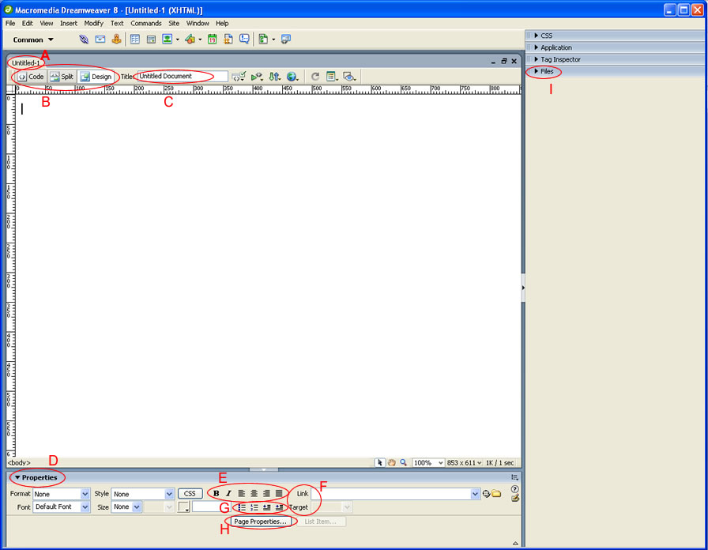
A – This is the filename of the document
B – This is to switch between HTML-only (code) view, and design view and split screen (half code, half design)
C - This is the title of the document. It will appear in the very top left of the browser window, as shown below. The title of the page below is ‘The University of Plymouth’

D – This is the Properties section. From here you can format the text (size, colour, font), create hyperlinks and access the properties of the page.
E – This is where you can change the text on the page to be Bold or Italic, and also the justification on the line (left, centre, right, justified).
F – This is where you can create hyperlinks. ‘Target’ will open the hyperlink in either the same window, or a new window.
G – This is to indent the text on the page, to create a numbered list, or a bulleted list.
H – This is where you can change the properties of the page
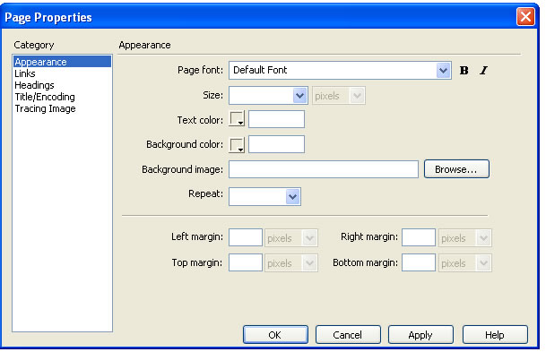
Figure 4
You can change the page background colour, the background image, default text colour here.
I – If you have defined a site in Dreamweaver, the files will be shown here. That is to say, if you have pointed Dreamweaver to the folder where you are keeping your files, you can see them here. (more about this further on)

The process of designing a website in dreamweaver
- Define your site – this just means tell DW where the site files are.
- Create a template design – (include all your styles and an editable region in here)
- Reuse the template design to create HTML pages (links and images to go in these files)

task 1: Defining a site in Dreamweaver
Dreamweaver has a fantastic interface for keeping the file structure of your web site in order, but you need to keep all your files in the same folder (e.g. graphics, images, documents, html pages etc.).
I always call the main folder WEBSITE – this is useful because you know that all the files within that folder will eventually be copied onto the server for web publishing.
- Go to Site > New Site from the main horizontal menu
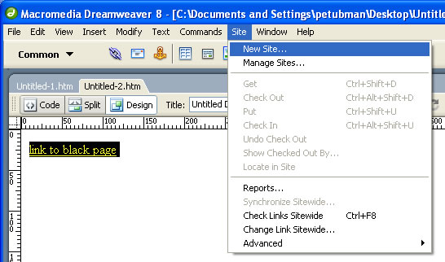
- Choose ‘Advanced’ (circled below), and fill in a name for your site. Click on the folder icon next to ‘Local Root Folder’ and navigate to the WEBSITE folder. You will need to actually be ‘inside’ the WEBSITE folder before you select to display your files correctly.
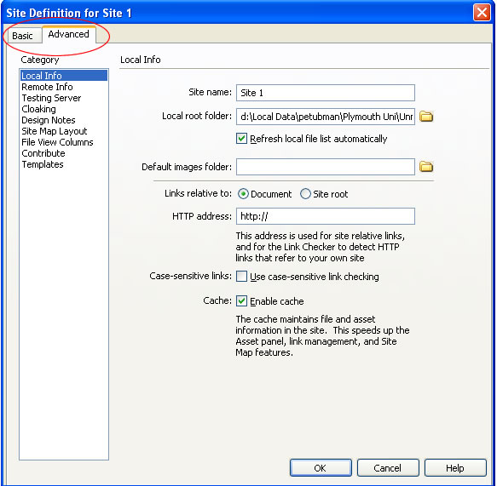
You can fill in the details of your FTP server (if you have one) into the ‘Remote Info’ window.
At the University of Plymouth, files are generally copied onto the server outside of Dreamweaver, so make sure it says ‘None’ for now.
Site Name
Local Root folder

- Select OK, and your site files should appear on the interface to the right. The website below has subfolders, and all the files in the site are organised into them.
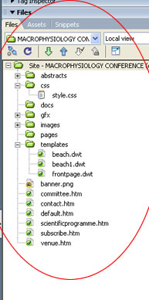

Task 2 - Creating a Template in Dreamweaver
To create a page layout, we need to use tables, as a common foundation from which we can build every page.
- Create a new, blank, HTML page (File > New > Basic Page > HTML)
- Choose Insert > Table, and look at the properties dialogue box which appears. Choose a table with 4 Rows, and 3 Columns, with a width of 100%*, (and for now a border of 1).
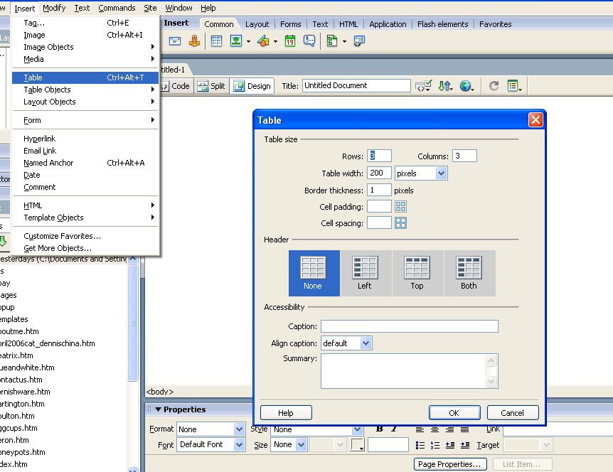
Q. Why do you think we are going to choose a width in percent, not pixel width?
A. SENDA compliance, although fixed pixel widths may be better for a tightly designed site.
- We are only going to use the central column in this table. The columns on the right and left are going to be left blank so that the page can automatically centralise itself depending on the size of user’s screens (see below).
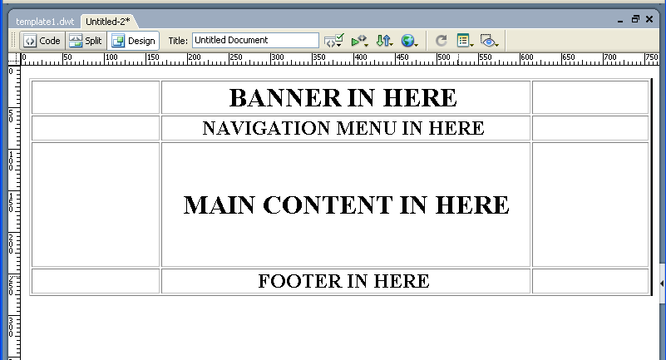
- If you have defined the site correctly, you will find that you have some files in the window to the right.
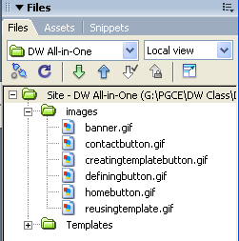
- Place your cursor in the middle column (where the banner is to go), choose Insert > Image and navigate to ‘banner.gif’. (This is 800 pixels wide and this will be the minimum screen size for viewing – it will be centralised because it is the middle cell)
- Place your cursor in the navigation menu cell and choose insert > image again. Place the buttons in this cell side by side as shown below.
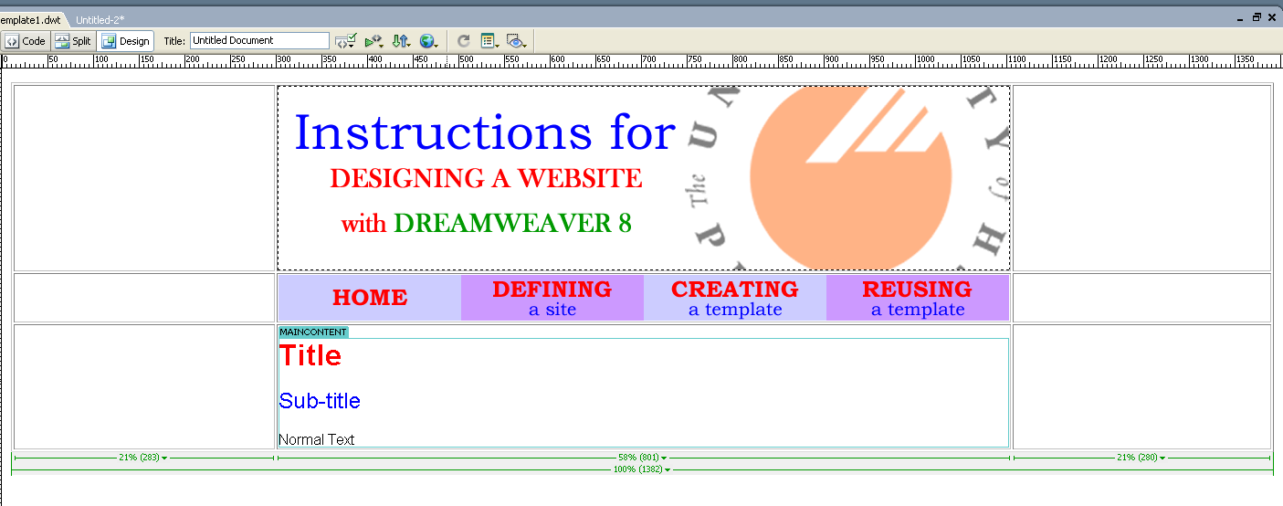
Drag the vertical sides of the central table cell to the edge of the banner image, as above. This will centralise the banner image on the page.
The banner is 800px wide, and the buttons are 200px wide (thus exactly 4 buttons…) This is why you should work out the image sizes beforehand…
- Place your cursor in the 3rd row middle cell (where main content is to go) and choose Insert > Template Objects > Editable region. This will come up with a dialogue box letting you know that this page will now turn into a template. Click OK.
- When you have the editable region showing on your page, you are ready to save the page as a template.
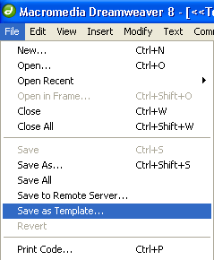
- The following dialogue box appears:
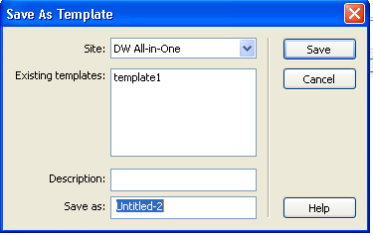
You can see now why it is important to define the site first. When this file is saved, it is a template specifically for this site, which can be reused easily.
- Save the file and click OK. You should find a new folder appears in your files, called ‘Templates’. All your templates are in here. Close the file down.

task 3: Re-using a template in Dreamweaver
- Choose File > New, but select the templates tab this time, instead of blank HTML page.
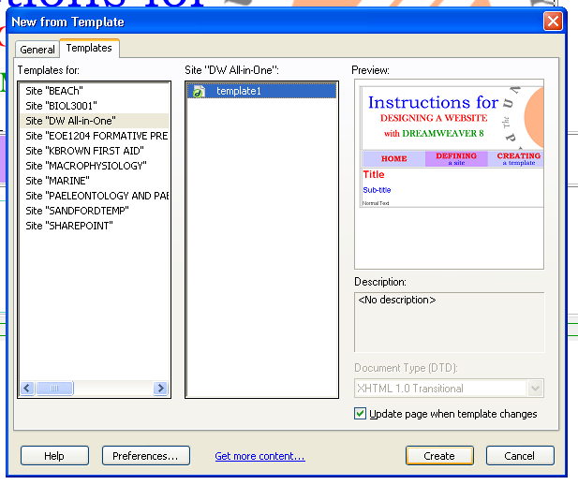
- Your page appears, but there is only 1 area you can type – the main content section (or editable region). You cannot select anything else on the page.
- Fill in the main content section with some text (including a link, and a link to a document)
- Repeat this 4 times so that you have 4 new pages created from the template. (I have chosen 4 because that is the number of button links in the template.)
- Save the files (the homepage MUST be called index.htm/html) and close them down.

Making the template link the pages together
- Open the template file again (using the files window on the right of the interface). Make sure all other files are closed.
- Select each button and use the crosshair next to the link property (shown below) to choose the file that button should link to:
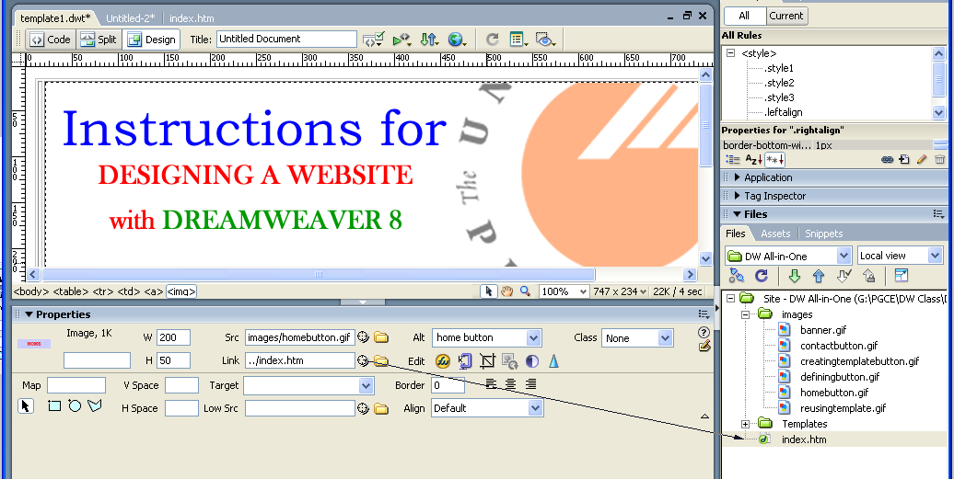
- Save the template and it will prompt you to save all files which use this template. Click OK to this.
- Select the table and choose border of 0. This makes the layout invisible. Save all the files again.
- Open index.htm/html. Press F12 for a preview of your site. All the buttons should work, taking you to a different page, but the template will remain fixed.

A word on tables
If you have ever used tables before (in Word for example), you are probably aware that they change the size of the cells, depending how much content is in. This is especially the case when you are using % widths rather than fixed widths, as the table moves according to different screens.
Dreamweaver has a way of designing in tables which removes this annoying feature.
Go to View > Table Mode > LAYOUT MODE (or cntl+F6) to see the table in a different way
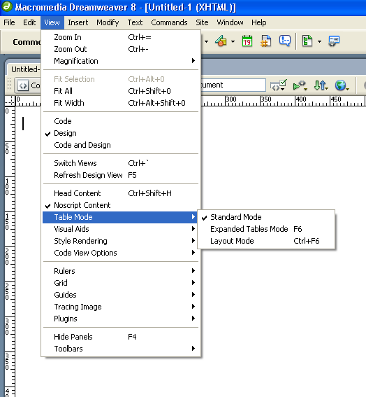
This makes all the cells selectable, and resizeable individually. You can draw in new cells to exact size here using insert > table objects > draw cell.

